Never let a poor credit history rating embarrass you

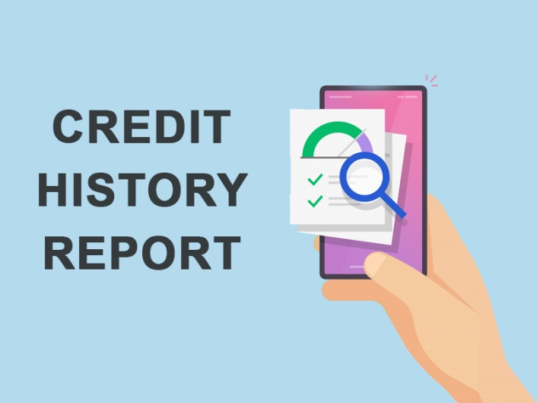

Did you ever face embarrassment and dejection when your credit application is rejected on account of poor credit history rating? Well then you need to learn a bit more on why it is important to have good ratings.

So, let’s start from the basics. First of all, let us understand that the ratings are awarded by certified credit rating agencies to companies to demonstrate a history of responsible borrowing. This means that when companies apply for loan to expand their business or to meet their expenditures, the prospective lenders take a look at it to assess the borrower’s creditworthiness. They use it as a tool to understand whether the applicant will be able to repay the borrowed amount or will falter.

The scale is an amalgamation of aphla-symbols that ranges from A++ to D.  And when the ratings are high, the lenders are more than happy to extend the loan and the amount gets disbursed within no time into your account and depleting ratings can get the loan application rejected.

So make sure your company has a history of good credit ratings and ranks high on the rating scale. Take a thorough look on the tips that will tell you how you can have a rocking credit history rating.

**Make timely payments:** It is a principal rule to pay off your debts first. This is because any late payments ranks on your credit rating report and could reflect in the history for years depending upon the intensity of the lapses you make. Simply put, every missed payment will create a negative impact to your [credit score](https://scocre.com/).

**Tip:** Try prioritising your credit and pay off the smaller loans and move on to the next ones.

**Maintain credit utilisation ratio:** Overspending could ruin your credit utilisation ratio and create a situation of possible default. This could eventually lead to a reduction in [your credit score](https://scocre.com/register).

**Tip:** Keep the debt utilisation ratio well under 35%. Doing so will help you pay off the loan without any trouble.

**Avoid any hard inquiries:** Every request you make for a new credit gets registered as a hard inquiry and frequent hard inquiries tag you as a person who is desperate for money and probably is unable to handle the finances. This goes against your reputation.

**Tip:** Opt for loan only when you need it the most. Otherwise making constant inquiries can hamper your credit history rating.

**Never opt for debt settlement:**When you approach your lenders to agree for debt settlement, it means that you will have to pay less than the actual amount you owe. This will get the lenders off your back, but in reality it would be reported to the credit bureau and the same will get reflected in [your credit report](https://scocre.com/blogs/credit-report-and-its-importance.php). This blot would stay on the report for years.

**Tip:** Try proposing the lenders to restructure the loan repayment as per your convenience.

**Conclusion**

So, if you follow these steps and keep your credit history rocking and in shape, you will always have an upper hand while dealing with lenders.